AUTH-013
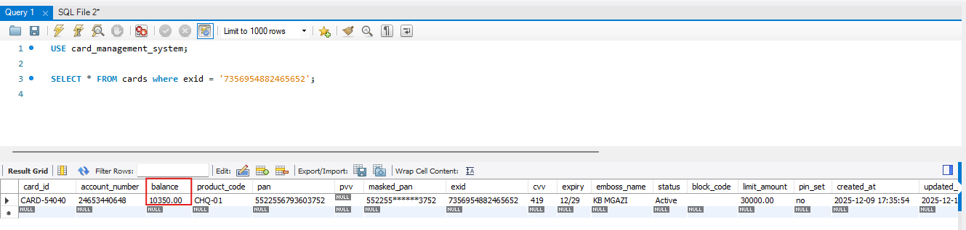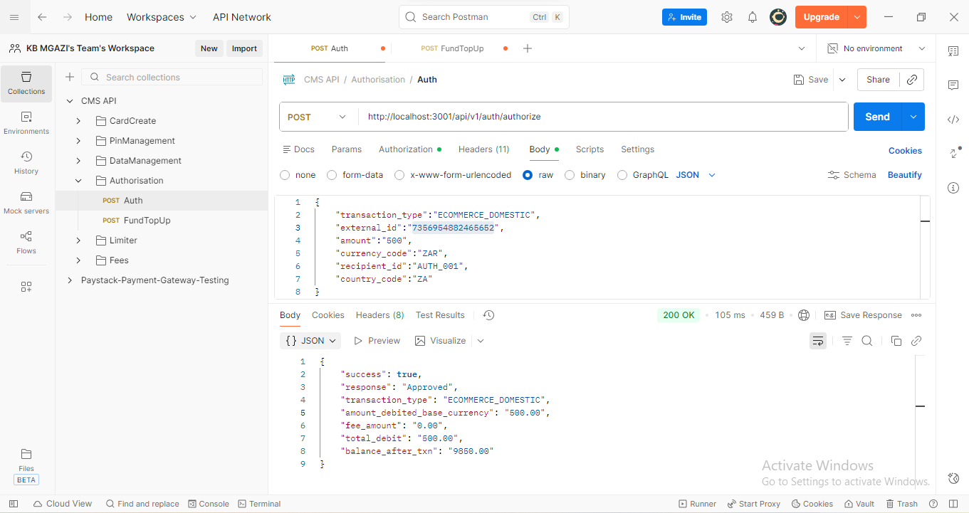
Request:
{
"transaction_type":"ECOMMERCE_DOMESTIC",
"external_id":"7356954882465652",
"amount":"500",
"currency_code":"ZAR",
"recipient_id":"AUTH_001",
"country_code":"ZA"
}
Response:
{
"success": true,
"response": "Approved",
"transaction_type": "ECOMMERCE_DOMESTIC",
"amount_debited_base_currency": "500.00",
"fee_amount": "0.00",
"total_debit": "500.00",
"balance_after_txn": "9850.00"
}
